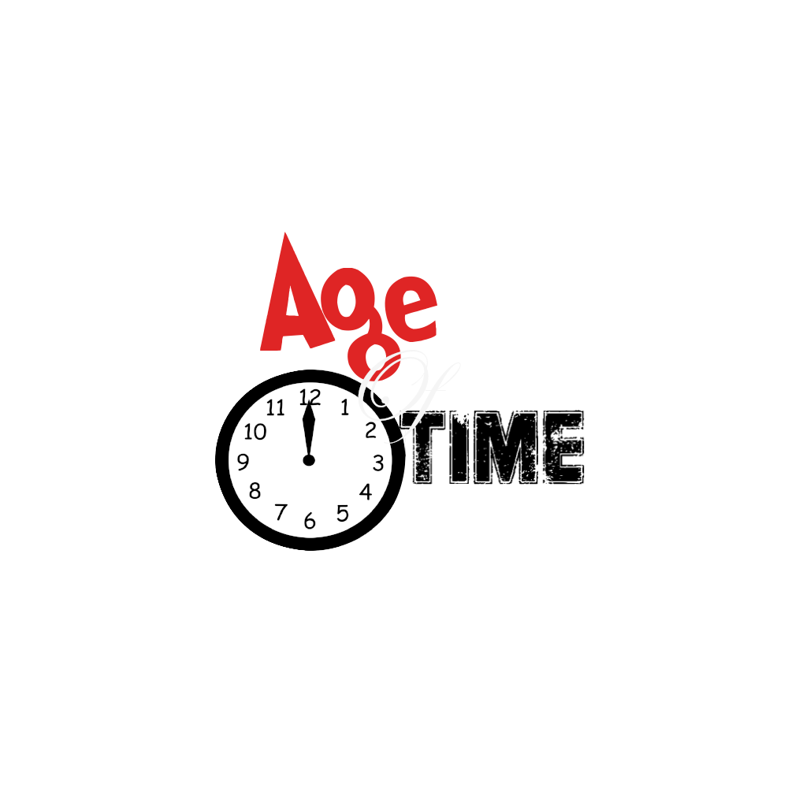

Table of Contents

**1.** **Overview** 4

**1.1** An Introduction 4

**1.2** Logo 4

**1.3** Theme 4

**1.4** Target Audience 5

**1.5** Why we chose the idea 5

**1.6** So, In Summary 5

**1.7** Mood board 6

**2.** **Level Design** 6

**2.1** Level 1 7

**2.2** Level 2 9

**2.3** Level 3 11

**3.Graphics** 12

**3.1** Characters 12

**3.2** Weapons 14

**3.4** Enemies 15

**3.4.1** Crab 15

**3.4.2** Eagle 15

**3.4.3** Jellyfish 15

**3.4.4** Snake 15

**3.4.5** Spider 15

**3.4.6** Wolf 16

**3.5** Other Assets 16

**3.6** Animation 16

**4.Production** 18

**4.1** Assets 18

**4.2** Source Code 18

**5.Sound Design** 18

**5.1** Music 18

**5.2** SFX 18

**5.3** Sourced Locations: 19

**6.Mechanics** 19

**6.1** Time Travel 19

**6.2** Jump 19

**6.3** Crawl 19

**6.4** Running 19

**6.5** Combat 20

**7 User Interface** 20

**7.1** Menu System 20

**7.2** Main title screen 21

**7.3** Start Screen 21

**7.4** Option Screen 21

**8. Controls** 22

**8.1** Keyboard and mouse 22

**8.1.2** Left handed Keyboard controls 24

**9. Art and Audio Production** 24

**9.1** Software used 24

**9.1.1** GIMP 2.0 24

**9.1.2** Bosca Ceoil 25

**9.1.3** Unity 25

**9.1.4** Spriter 25

**10. Project management** 25

**10.1** File management 25

**10.2** Team Meetings 27

**11. Use of GitHub** 28

# **Overview**

## An Introduction

We were asked to come up with a project in a team, so we decided to come up with an idea for a game called ***“Age of Time”.*** We wanted to come up with a unique idea for a game that hasn’t originally been developed before in which we came up with the thought of making a game based on puzzling and platforming to common genres that are merged together but add a mechanic that is totally unique to its genre and to games. The ability to change time in game by transforming from a baby, teen and adult. The idea is that the player has a certain amount of turns to complete a level in which there will be platforming and obstacles like enemies that get in the way of you achieving your goal, each player character has a unique quality to them meaning you need to use thought to figure out how you are going to complete a level.

## **1.2** Logo

Here is the logo for the game Age of Time.

The meaning of the logo is that the font displays the slow decline of change. Age displayed in red shows a more youthful look giving the logo some pop. The of is white and is classful as you make yourself the best you can be to make it in the world then Time displayed in black is deuterating almost gone from existence. The clock is a simple look that just represents time.

## **1.3** Theme

When designing the game, the theme became the most important aspect of the game since nailing a theme for the game that can appeal to the clear majority will always remain an underrated talent in the industry as a good solid theme can change the whole outlook of a game. ***Age of time*** is themed around changes and time travel the knowledge that in life things change you go from being a mumbling crawling baby to be a grown vertical strong boned person whilst you are changing so is the weather and that is the common theme of the game that change happens.

When deciding the theme of the art style of ***Age of Time*** we wanted to go for a more cartoonish style as we felt that this approach would gather much more interest from the vast majority of players as a theme around realistic shaded art would take up too much time but also add too much seriousness into the game when we are aiming to make a fun puzzle game.

We also want to include some aspects of retro gaming to ***Age of Time*** as it will bring some joy to the retro gamers that play the game and will give the rest of the players some insight on how game music was when it first started.

## **1.4** Target Audience

When creating Age of Time, we wanted to make it accessible to everyone from people that have never touched a game before to hardcore gamers that could also just enjoy a nice indie game.

This way of thinking of trying to lure a whole new person into games would give us challenge but also a sense of gratification that we managed to take someone not so interested in gaming into a casual gamer.

We also wanted to target fans of time travelling as that was the key mechanic in the game.

## **1.5** Why we chose the idea

We choose the concept of Age of Time because it is such a unique experience in games especially in 2D not many games if any have a feature in where you can change back time.

This gives us our own niche into games and lets us start a possible trend in time travel in game.

We also chose this idea as it gives us more opportunities to create more unique art and level design.

## **1.6** So, In Summary

The game is going to be a unique 2D platform puzzler game that will bring a whole new player base into games, it will also include the whole new aspect of being able to change character in game through time travel. The game is aimed to be a fun game based in a cartoonish style making the game more appealing to all age ranges and not just a select group of players as we don’t wish to exclude any potential players to be playing our game. Lastly, the game will be based around retro gaming in which the sound design will have an 8-bit sound design to it giving a fun appeal to retro gamers.

## **1.7** Mood board

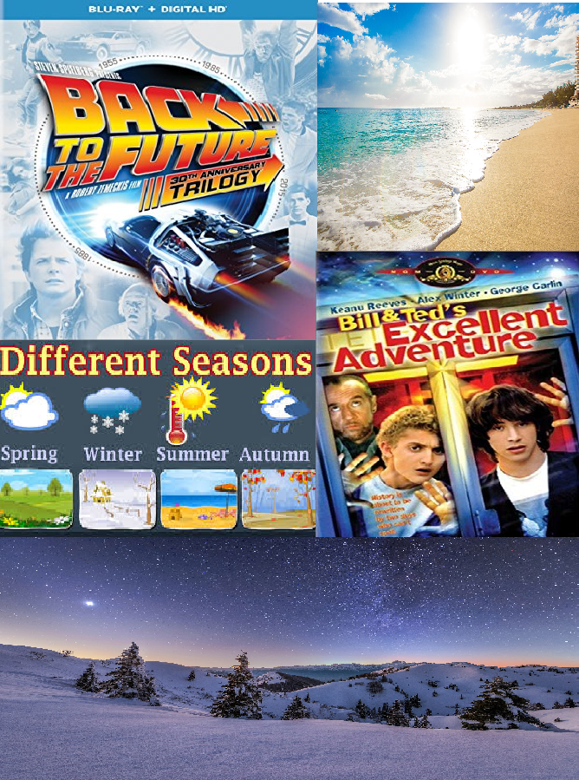

Here is a mood board showing some inspirations behind the project such classics as time travel movies as ***“Back to the future”*** and ***“Bill and Teds excellent adventure”*** played a huge part in the influencing the game idea.

# **2.** **Level Design**

When creating the game, we had to think of a way to make the game make sense with everything else that’s included such as the ability to change time and we thought what else changes throughout time? The seasons. That’s why we decided to include three levels based on three of the seasons the Spring season in which you are indoors then moving onto the second level in which you are in a sunny summer’s beach which then traverse’s into a final area in which it will be winter this will play out the feeling of going through the seasons as it changes.

## **2.1** Level 1

When creating the first level we decided to include a tutorial level where the player can get used to the game and how the mechanics work so firstly we went for an indoors level based in spring you try and escape the home to make it into the next level where you are introduced to the summer level.

When creating the art for the level we wanted to make a mix of 2D and 2.5D in the game making more unique design choices in this level you will notice that the stairs and boxes are 2.5D whilst the backgrounds and platforms are 2D

Here are some backgrounds in the first level and assets:

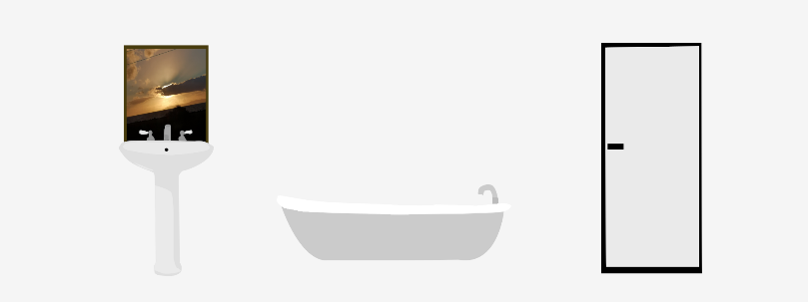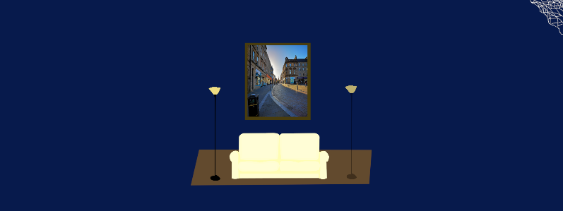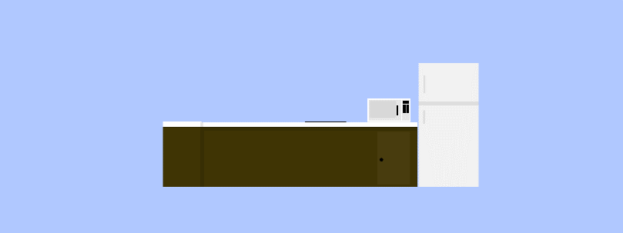

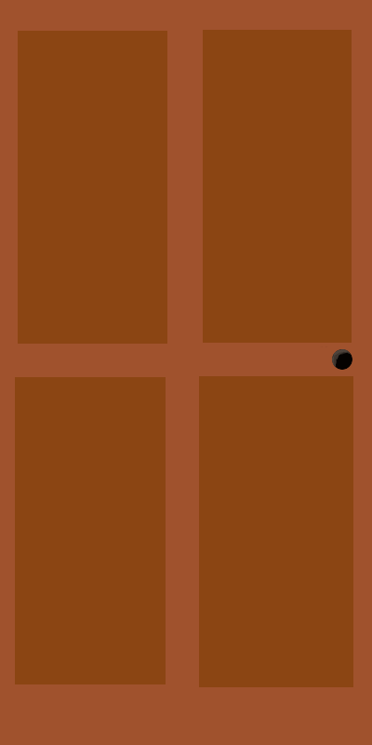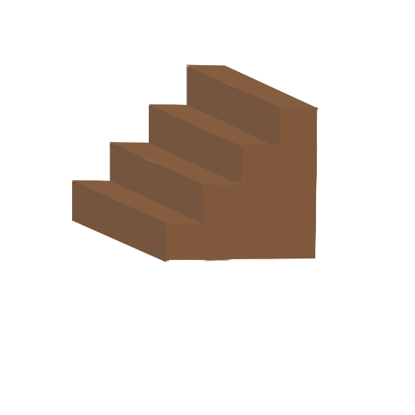

As you can see straight away that the point of the 2D to 2.5D aspect is in their all assets for the level were created by the team’s artist on ***GIMP 2.0***

**Here is the level in action:**

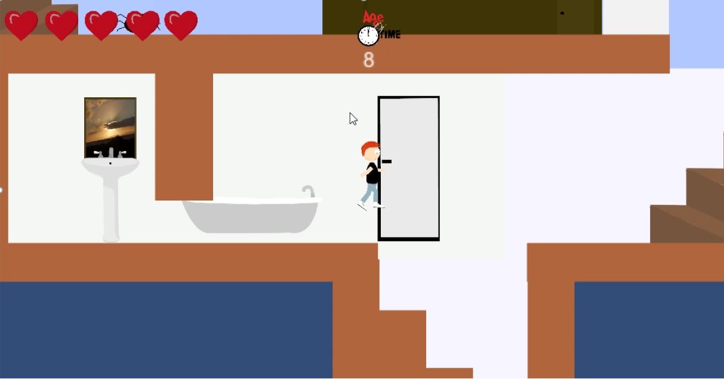

## **2.2** Level 2

On level 2 we wanted to make a summer level in which the player jumps down a brick wall onto a beach where they must find a key to get to the next stage this level design idea was down to the common denominator for summer which is sunny beaches. The background is completely made from GIMP 2.0 too from scratch from the artist in the team. We wanted to make it look people are on holiday as a French person has their towel on the sand with a sand castle beside it with lounge chairs across from the towel.

**Here are some of the examples of the backgrounds included in the game:** 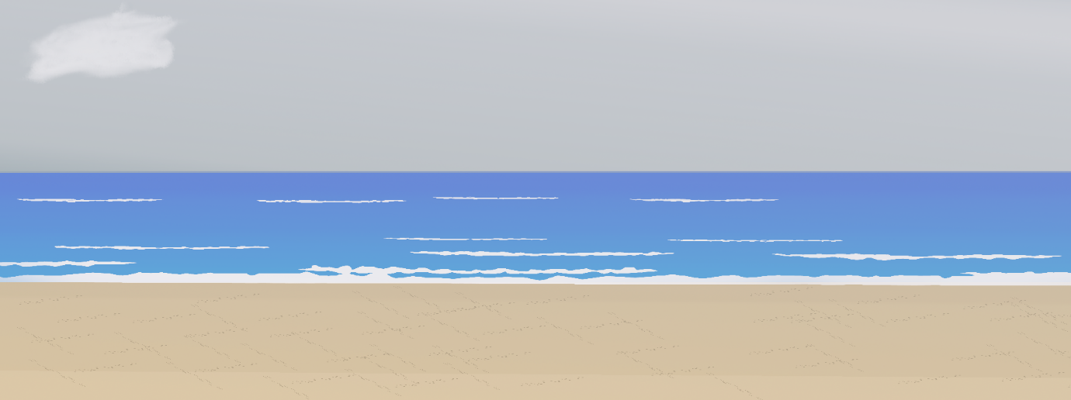

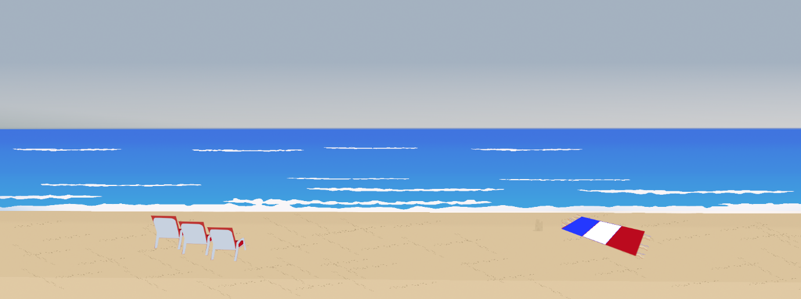

As you can see the level is very well put together by the team’s artist and by far the nicest piece the artist produced.

**Here is the Level in action:**

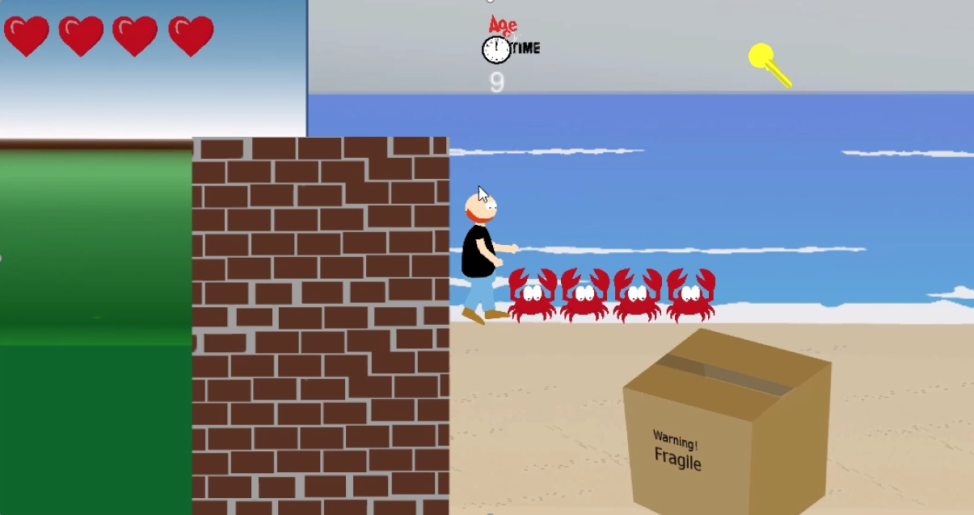

## **2.3** Level 3

Level 3 is based on the winter, so the player is trying to reach the ending of the game. The player must traverse onto the top of the mountain to get to the end of the game. We decided to include ice spikes onto the bottle of the level so if you fall off you are in risk of dying but you can get back up by the lowest platform on the level you need to find keys to get to the end of the level.

**Here is some of the assets that contribute to making the level:**

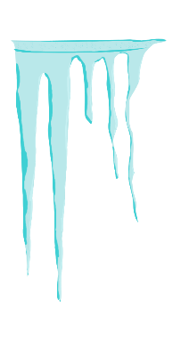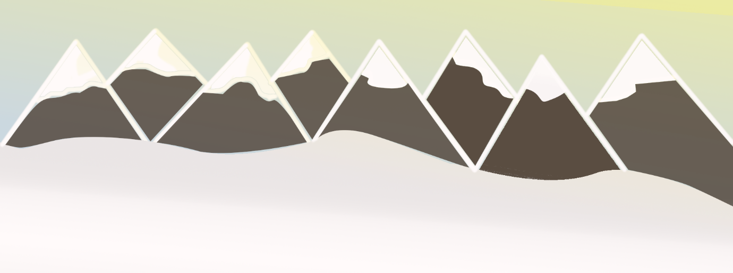

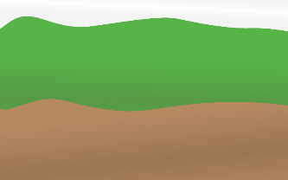

As you can see the assets of the level fit the concept of the level. The mountain is shaded with lighting, the grass block has been snowed over and the ice spike is capable of any character.

**Here is the Level in action:**

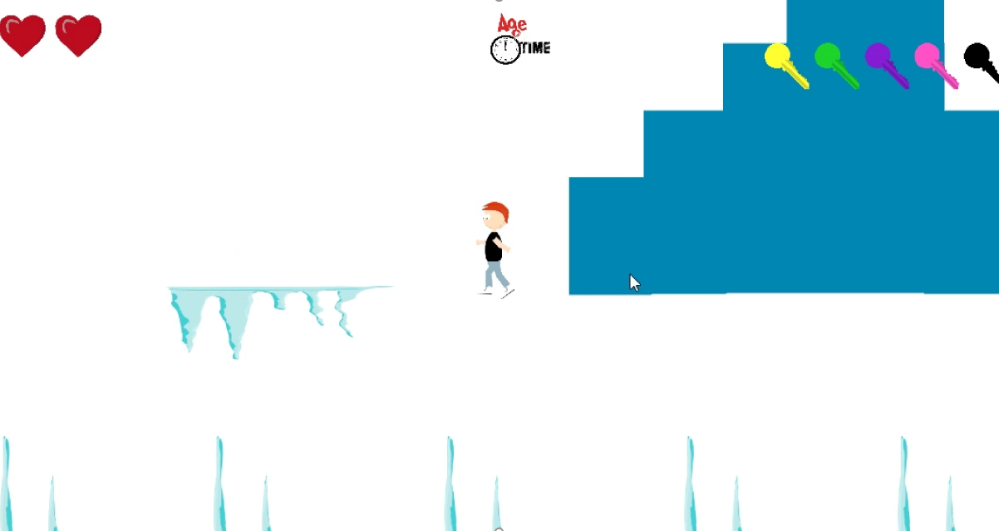

# **3.Graphics**

When deciding on how the game would look we discussed as a team on how the art should look at first we were thinking of a more 60’s Disney type of style like ***‘Cuphead’*** but we also decided that this would be too much imitation and it would take too much time up so we decided to create a basic art style that would be unique in the aspect that no characters would have a nose, mouth or ears to give it a more unique art style.

## **3.1** Characters

Baby

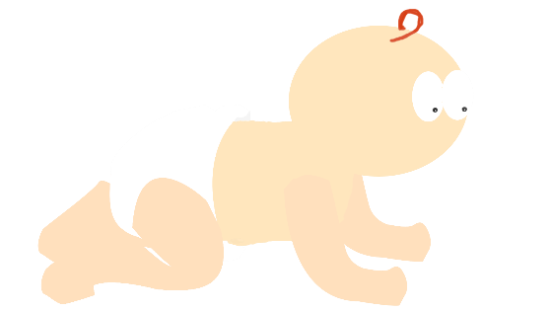

When creating a baby, we needed to think of how the baby would move so we decided the baby would just crawl from the go as most babies cannot walk, we decided to make the character red haired, so the one link of hair shows the signs that the baby will be a ginger child.

Teen

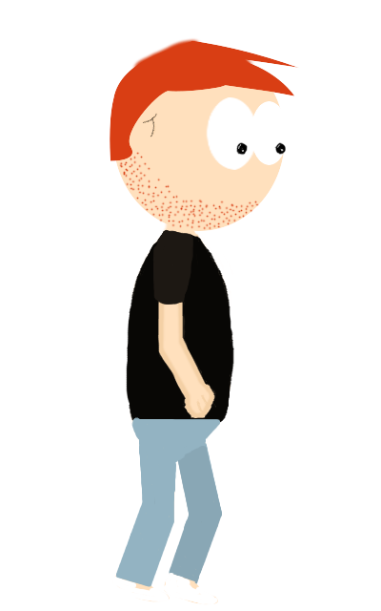

The teen was designed on the bases of how you develop as a human from a baby you start to grow a head of hair and you style it to make it “Cool” and have facial hair growing in but it hasn’t fully developed into a beard yet.

Adult

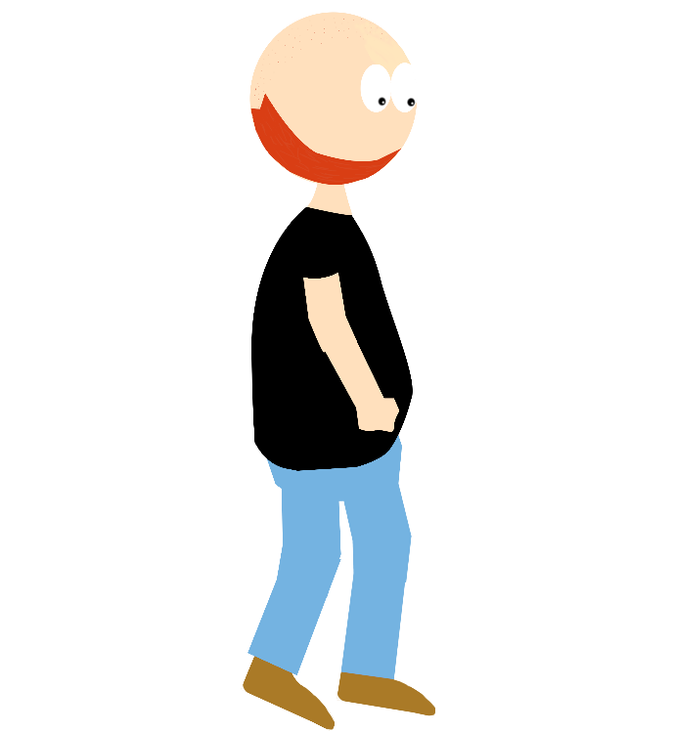

The adult was designed to be a brawler, so we gave him a very top-heavy look and his hard life of being a brawler and having too many beers has resulted in him being bigger with a bald head.

## **3.2** Weapons

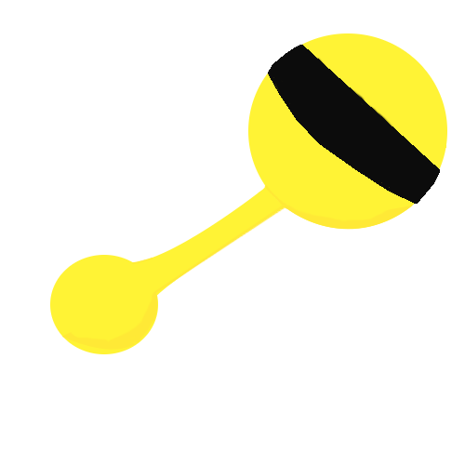

For the projectile weapons for the baby we had to think of the type of weapon a baby would use so we came up with the concept of the baby rattle as it is a very common item a baby would use and it quite a heavy item.



The adult and the teen use the phone as a projectile as a common item as both teens and adults use phones as daily objects it made sense that it would go hand in hand in making it a weapon.

## **3.4** Enemies

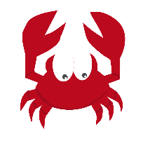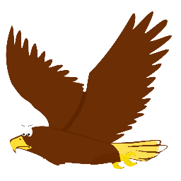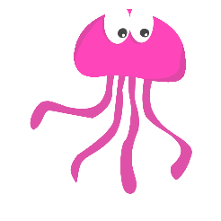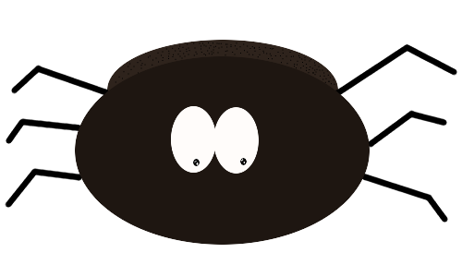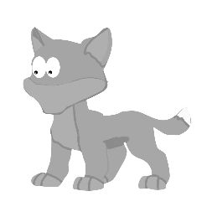

### **3.4.1** Crab

The crab was designed in for the summer level as you see many crabs patrolling beaches and summer locations. It also is a very aggressive creature if you invade its privacy too much.

We went for a simple red design as that is what crabs are usually associated with and add some shading to the arms and legs to distinguish what part of the crab it is and like every character in the game the crab has the iconic eyes-only art style.

### **3.4.2** Eagle

When thinking of winter creatures, we thought of plenty of ideas of potential animals, but one came to mind straight away that is the bald eagle it’s a mountain-based bird that lurks on prey and is unforgiving with its speed and timing. We decided on its colour scheme as it would be a disrespect on the animal to make it a different colour.

### **3.4.3** Jellyfish

When creating the jellyfish, we went for a fun style that gives the jellyfish a goofier look too it as we want to appeal to everyone we feel making the enemies too intimidating might put off some younger players.

We went with the pink shading as it’s a common theme for a cartoon jellyfish to be and finishing it off with some eyes-only art style.

The jellyfish is also based in the summer level as it’s found commonly on beaches or the ocean.

### **3.4.4** Snake

It’s not every day you come across a snake on a beach but in the summer level on the beach you are sure to find one slithering towards you as you try to find the keys to get to the other stage.

The reasoning behind the colour scheme is that the most common colour drawn on a cartoon snake is green.

### **3.4.5** Spider

The only creature you’ll come across when you are in the first tutorial level in the spring home as you try to escape the house.

The spider is designed to look the goofiest of all the creatures with huge eyes as it gives them a less threatening look and makes the game true to its aims of being a fun all ages game.

### **3.4.6** Wolf

When creating the wolf, we realised how goofy it’s going to look without a nose or mouth but we decided to go through with it as it’s a solid winter animal that is such a dangerous animal that could strike any human down.

The reason for the colour scheme was just to keep on point to keep the colour scheme accurate to real life.

## **3.5** Other Assets

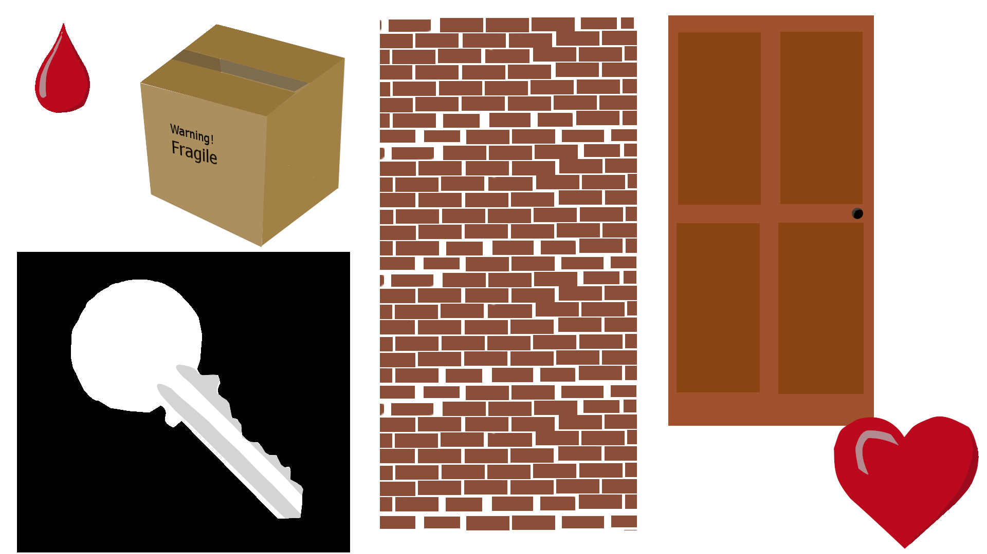

## **3.6** Animation

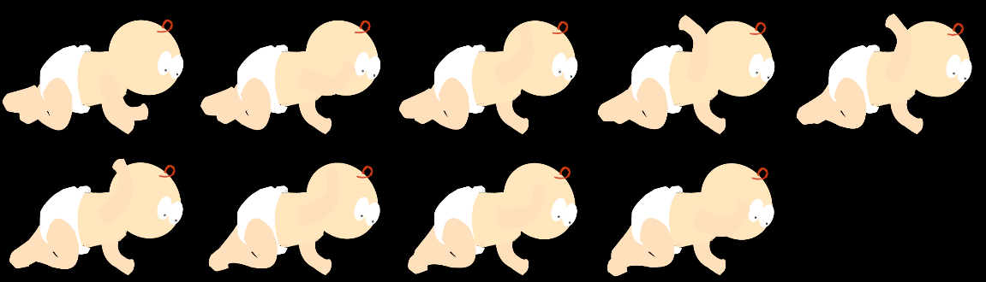

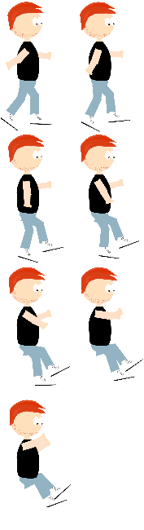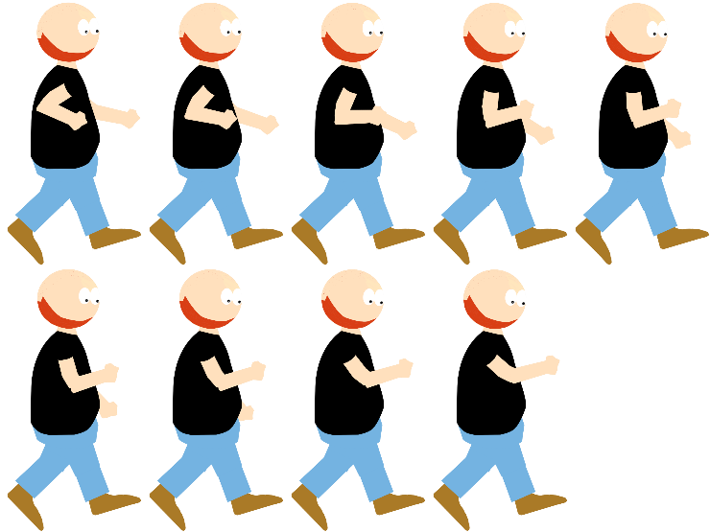

When producing the animation for the characters we had to come up with a method of doing the animations, so we decided to use ***Spriter*** the free version to create the animations as we have experience using the software from previous projects so we made the animations then converted them into sprite sheets that would make the implementation onto the game a much more smoother experience rather than doing individual art for each movement this would also make the process a much quicker route into making the animations.

Having to create the animations we had to make the character in separate pieces so individual head, body and legs and combining them all together onto ***Spriter,*** here is an example of a pieced-up character that is ready to be used in spriter:

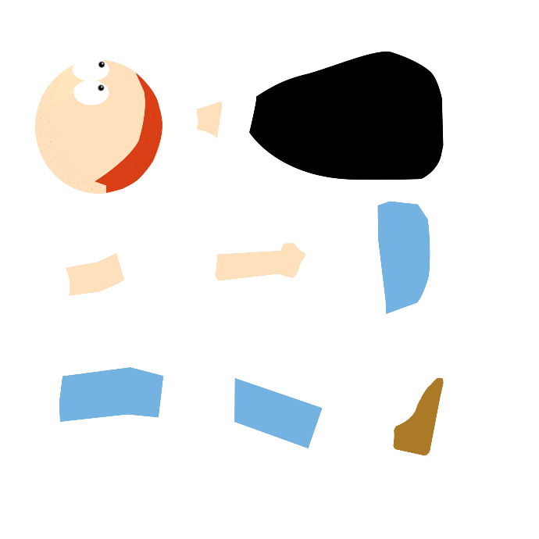

That above is the adult in parts ready to be animated. The folder structure looks like this:

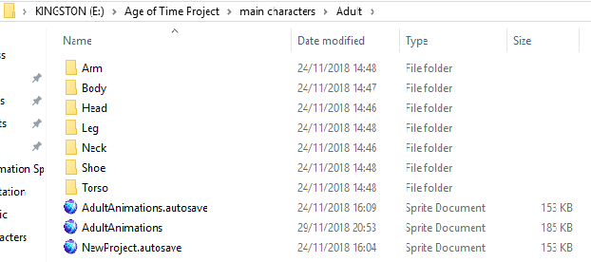

As you can see the adult is carefully place in parts to make the process a much smoother experience for the animator to access each part easily.

The pictures above are the sprite sheets used in the game for some of the animations as you can see the baby, teen and adult all have 9 separate images to create each animation to make the motion much more consistent as you can see the baby is throwing, the teen is jumping, and the adult is performing a punch.

# **4.Production**

## **4.1** Assets

## **4.2** Source Code

# **5.Sound Design**

## **5.1** Music

When creating the music of the game we had to think what would suit a 2D game which the most challenging part of the game we managed to source brilliant retro chiptune music that was royalty free music.

The decision for chiptune music is that is what we wanted the theme to be a retro style theme of the sound which chiptune provides, chiptune a genre in which music was played out of the ***Gameboy*** where such huge artist like ***Sabrepulse*** and ***Mohawke Hudson*** started.

## **5.2** SFX

When creating the sound effects for the player we need to match it with the chiptune style, so we sourced some content from opengameart.org in which we managed to have the player experience retro sound design similar to such games as ***Super Mario.***

|  |  |
| --- | --- |
| File Name | Source |
| Spider Chattering | https://opengameart.org/content/spider-chattering |
| Jump_01 to Jump_11 | https://opengameart.org/content/platformer-jumping-sounds |
| Breathing warning | Own Creation |
| Finding Key | Own Creation |

## **5.3** Sourced Locations:

# **6.Mechanics**

## **6.1** Time Travel

The time travel is the standout feature that makes the game unique from other games with the ability to reverse in time to a baby to fast forwarding yourself into the a man to get access to different areas of the level depending on the type of character you are; you can gain access to this mechanic by pressing the number keys 1,2 and 3 – by pressing the number one you’ll become the baby, by pressing number 2 you will become the teenager and if you press number 3 you become the adult.

## **6.2** Jump

The jumping mechanic can be used by the teenager, adult and the baby but they all have different capabilities on how high they can jump.

Baby – The baby can only jump in such a small vertical height as it hasn’t totally developed the muscle to be able to push high enough to get any real elevation.

The Teenager – This is where the teenager becomes a much more useful character as he is the one that can gain the most velocity and height when jumping letting him get to higher areas where the baby and adult can’t.

The Adult – The adult can also jump but as he is a brawler he is only able to jump in such a small height much like the baby he won’t be able to reach areas in which the teenager can reach.

## **6.3** Crawl

Crawling is a feature only the baby can do as it gives the baby a unique mechanic to be able to get to place the teenager and the adult cannot giving the baby a specific use in the game. This mechanic is planning to be implemented by putting the baby in vents to be able to get places to help achieve the goal that is required to in the level.

## **6.4** Running

Only the adult and the teenager can run but in different styles and speeds for different obstacles that are in the way you may not need to change to the teenager from adult if the obstacle is lower down. The lower the obstacle the less likely you will be needed to use the teenager. This mechanic has been implemented in the game as it is a common game design practice but to also make the player think they must use a rewind/fast forward to complete the task that’s given to them.

## **6.5** Combat

All characters can engage in combat in different strengths and capabilities we mainly made the adult stronger to give him his mechanical purpose and to give him a special ability like the baby with crawling and the teenager with the athleticism – the combat system can be accessible on keyboard with the left mouse click and on controller the right bumper.

#### **6.5.1** Baby

The baby delivers the least amount of damage to the enemy as a baby hasn’t fully developed so it’s throwing power is near none existent.

#### **6.5.2** Teenager

The teenager manages to cause more damage than the baby but will also take a few hits to manage to defeat the enemies.

#### **6.5.3** Adult

This is the special ability of the adult and can deal significant damage to any enemy as he has throwing power unimaginable to the other two and can easily take out the enemy that’s in front of him like anime series “***one-punch man***”

# **7 User Interface**

## **7.1** Menu System

When developing a menu system, you want to make it very streamlined while making it as thorough as possible.

As a team we set out deciding what would make a good menu system. We decided that the menu should consist of a title screen to give the player a introduction of the game, a start screen to let the player start from the second screen but also has a option and about section for players that like to adjust things in the game to suit their play style and for players that enjoy the game to the point that they are intrigued to find out who created the game and what were the reasons behind some of the design choices.

The animation & artist – ***Brendan McNally*** thought it would be a good idea for the menu to introduce all three characters baby, teen and adult. The baby would be the introductory character then depending if the player selects option or about they’ll be introduced to the teenager and the adult.

### **7.2** Main title screen

The main title screen is the introduction to the game with the logo of the game with the simple options of Start and Exit. This design choice was taken place as it makes everything very basic and simple for every player to understand.

### **7.3** Start Screen

Once you have selected start from the main title screen you are then taken to the start screen which introduces the baby character with the buttons start, options, about and back to select:

#### **7.3.1** Start

The start button takes you to the game which will begin from where the player last left off from. If it is the first time the game is being started, then you then begin the game from the very beginning.

#### **7.3.2** Options

The option screen takes you to the option menu which lets you control the sound.

#### **7.3.3** Back

Back will take the player to the title screen which lets them either look at the logo of the game or exit of the game.

### **7.4** Option Screen

When you select the option screen it will trigger a fast-forward animation showing the baby turn into a teenager this is due to the developers wanting the player to wonder what is happening with the baby turning into a teenager and what that has to do with the game.

You will be greeted with a sound, difficulty and a back button – Sound: letting the sounds be adjusted, difficulty: letting the player control how difficult the game is, back: taking player to the previous screen.

#### **7.4.1** Sound

This sub menu will take you to the sound menu which will give you three slide bars to determine the level of volume coming from the game firstly you have the control of the music volume of the game, secondly you have the sound effects of the game (SFX) which will be the sound of the character walking, running, shooting and ambient sounds of the game and lastly you have control to determine the sound of the dialog being played if the voices are too loud in-game.

#### **7.4.2** Back

This is a simple back button which will trigger to get the game to go back to the start screen; it will play an animation which makes it look like it’s rewinding back to the start screen as the teen rewinds into a baby.

# **8. Controls**

When deciding on what the controls should be we wanted to make them as easy and fluid as possible to give players of all abilities the chance to get to grips of the game as many gamers are console gamers we wanted to make the transition from controller to Keyboard and mouse a more smoother transition as the developers of Age of Time had personal experience of how challenging that transition can be. We also wanted to add a unique feature and include a left hand quick binding change as one of the developers being left handed has had previous issues with key binding.

### **8.1** Keyboard and mouse

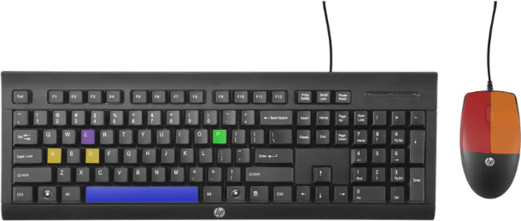

All controls are colour coded as shown.

A and D – Movement to left and right

E – Interact

P – Pause

Space - Jumping

Left Click – Attack

Right Click – Ranged Attack

### **8.1.2** Left handed Keyboard controls

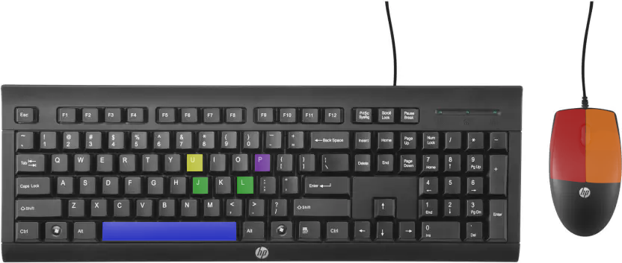

J and L – Movement for left and right

U - Interact -

P - Pause

Space - Jump

Left Click - Attack

Right click – Ranged Attack

# **9. Art and Audio Production**

## **9.1** Software used

When designing the game, we spoke about what type of software we would uses to produce ***Age of Time,*** so we went for programmes we are used to using, we had some issues with the art package used as the artist was used to photoshop and not the software used to create the sprites.

### **9.1.1** GIMP 2.0

When creating the art our artist had to learn a whole new art package in GIMP 2.0 overall it was a very fluid transition into learning the package although it could have been a much better art pieces if the artist was to use photoshop as that is what they are used too using.

Overall the use of the software was relevantly fluid, and it was a good alternative to photoshop that is a free application.

### **9.1.2** Bosca Ceoil

We used Bosca Ceoil for some of the sound effects in the game as we wanted to include unsourced audio in the game, so we created a heart beat in the game that would let the player know they are about to die based on the speed of the heart beating we had to figure out how to make it work.

Using the application for a team that know minimal on music and sound effects creation was easy to use and very intuitive.

### **9.1.3** Unity

### **9.1.4** Spriter

We used spriter to create the animations for the game as that is what the animator was used to using and you can access a free version of it that lets you export sprite sheets in which we needed to use to add it into unity.

Overall the use of spriter created some life into our game that took it from an alpha state to a more polished look which has left the team delighted on the finished piece.

# **10. Project management**

## **10.1** File management

When creating the project, we wanted all files in the game to be neatly placed into folders so that things wouldn’t get lost. We kept most of the work on one USB with using GitHub as a backup to files in case of the USB getting corruption.

**Here is how the folder looked when opened:**

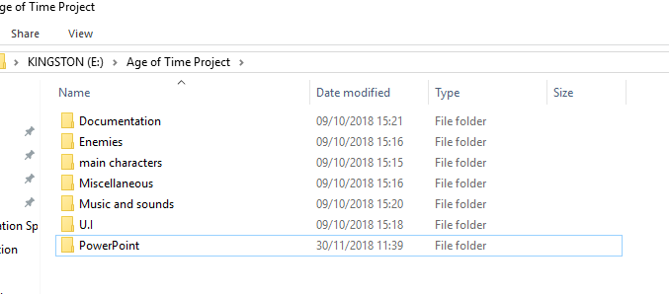

As you can see the folders are very well put together so that we don’t lose any files easily and to keep everything in order.

When opening a folder, you can see a png file for every sprite with the raw file too, so the artist can make some adjustments if they need to make any:

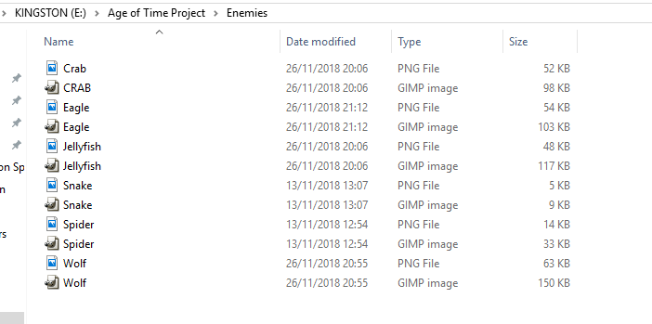

With the main characters they had the parts in one folder to make the animation then a separate folder for the sprite sheets so it’s easier to access rather than risking any corruption to the animation files and to keep it neat.

You will also notice that there is also a PNG and a raw file for the characters also: 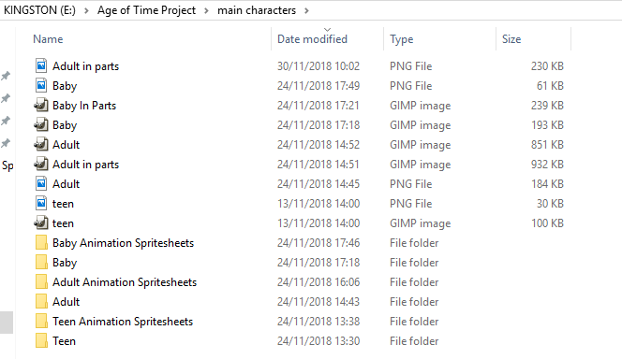

## **10.2** Team Meetings

To keep up to date with what was to be done we decided to produce a team meetings sheet to keep record in what we discussed and how to keep ourselves updated. This would include what we did on that day and then a projection to what we must get done in time for future meetings.

**Here is an example of what a team meeting would look like:**

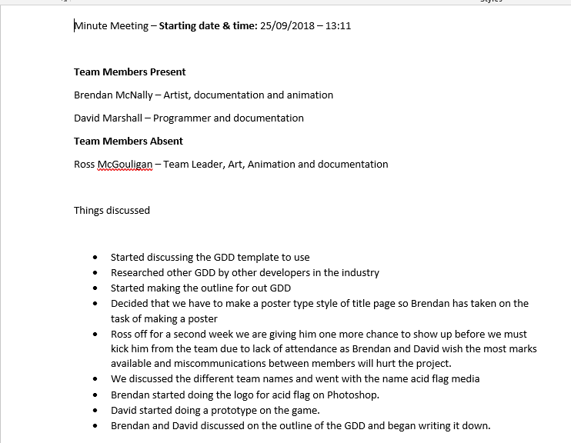

This would keep the team structured and help the team do what is needed to finish the game.

# **11. Use of GitHub**

To transfer files between the team we used industry own ***GitHub*** we managed to successfully transfer files between each other and keep the whole team up to date on what has been produced into the game.

Here is evidence of how we used GitHub to transfer files and to use the site as a backup for our work. 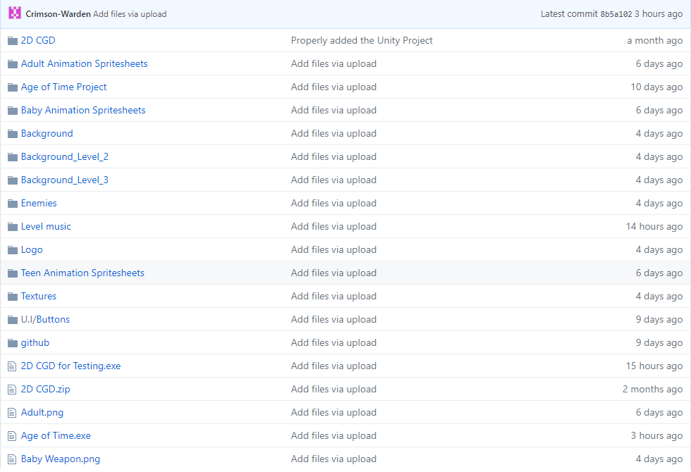

As you can see we used the site to have backup and to keep everything up to date between the team.